EXPERIMENT-1,2

CICD

NAME -ARSHPREET KAUR

SAP ID- 500094140

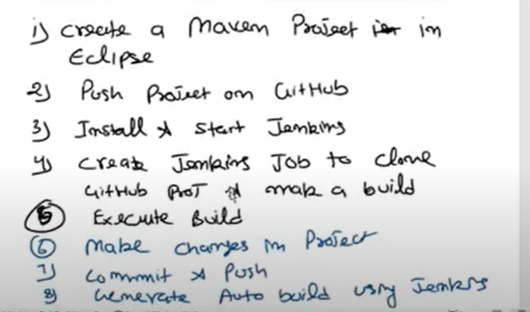

1. Make an eclipse java project

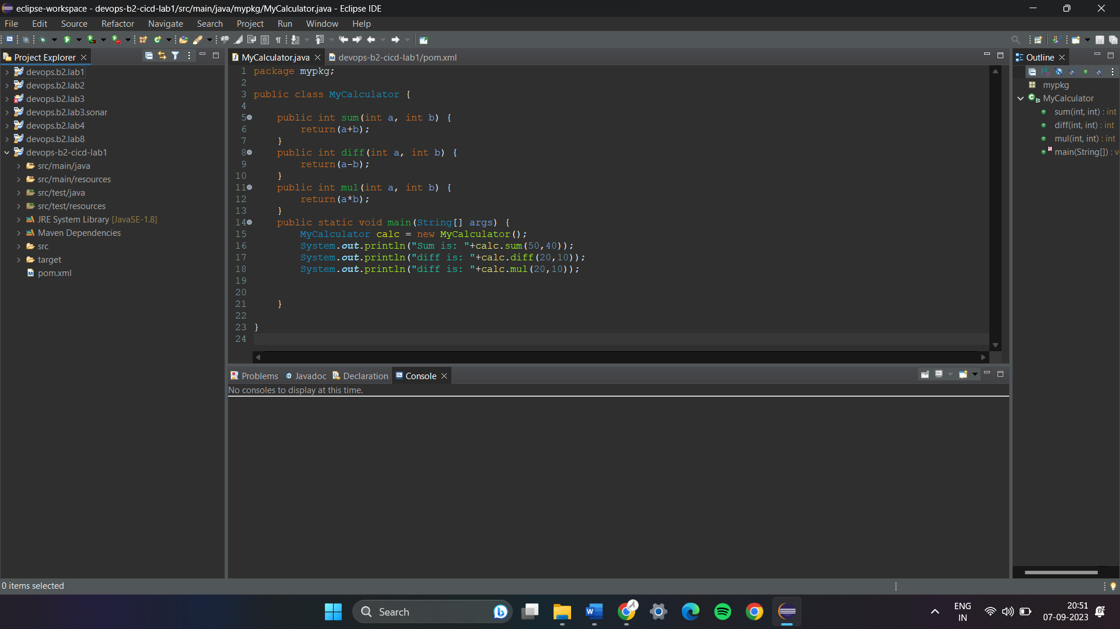

1. Create a github repository and push this code

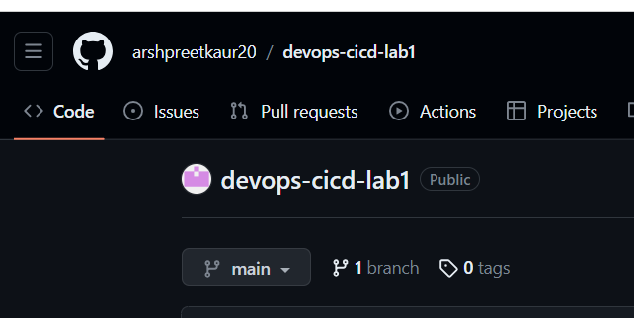

1. Open git bash for java project

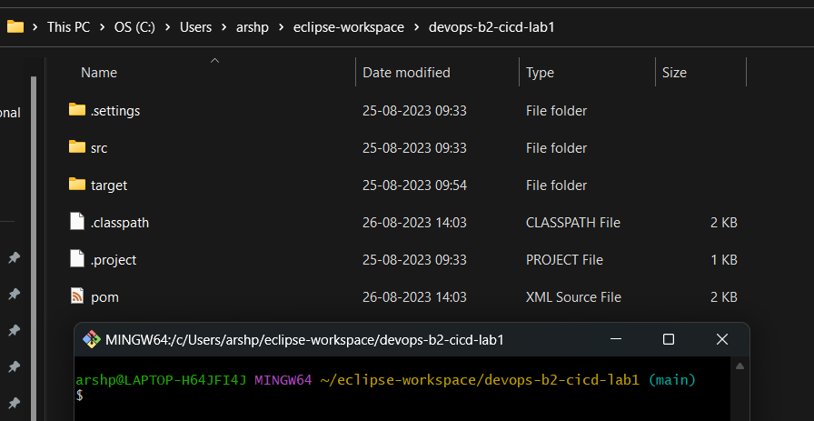

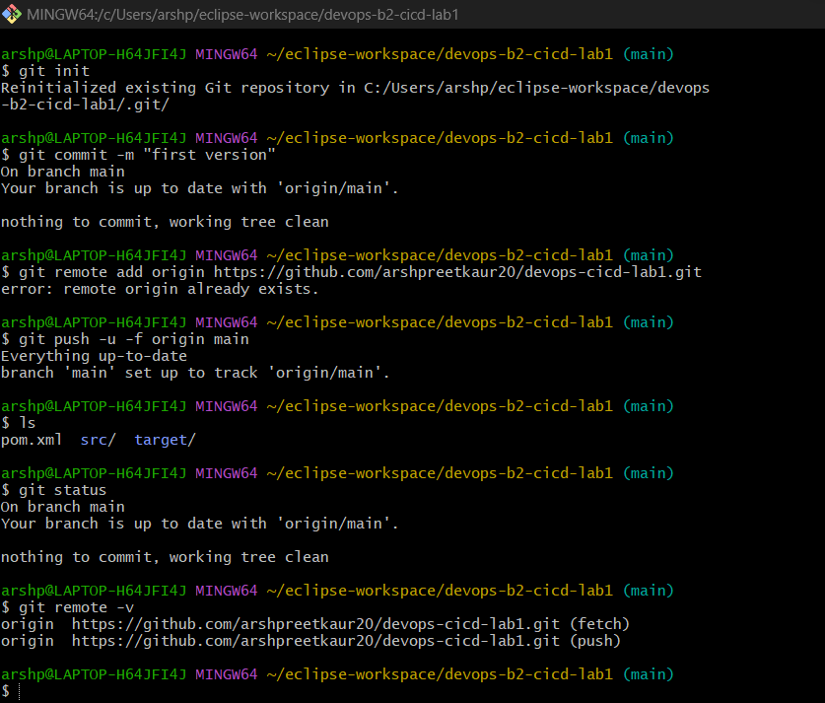

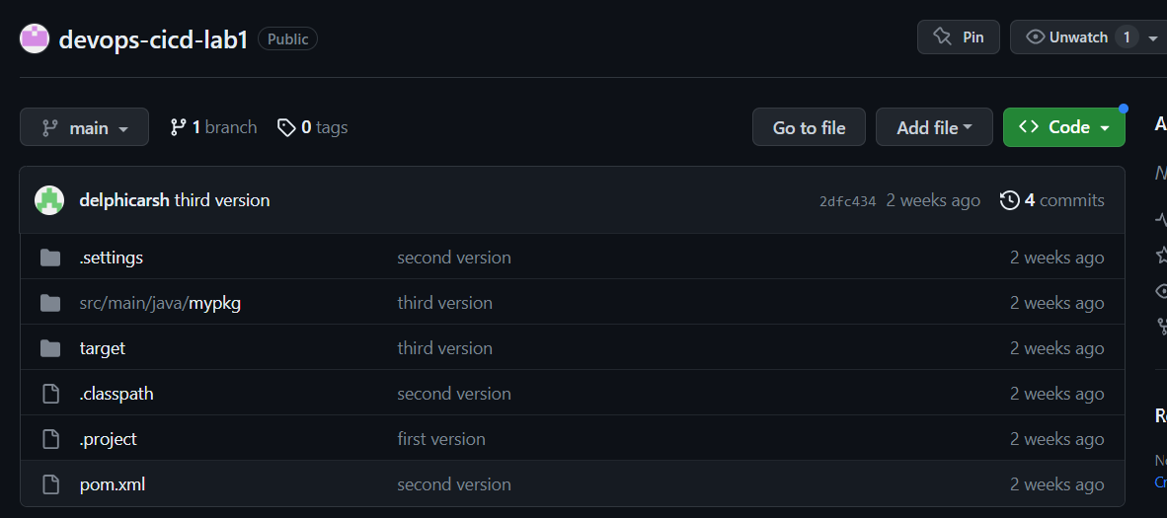

-do changes in pom.xml

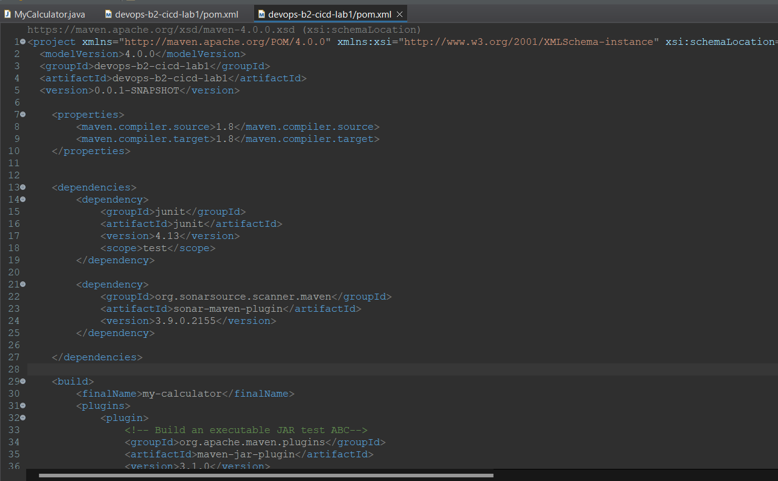

* Run as maven generate sources, a build would be generated.

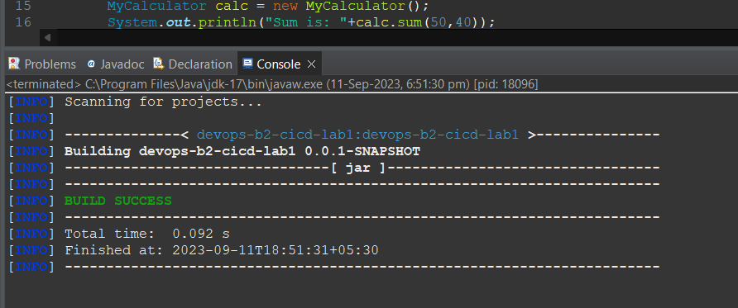

* Again push it on github

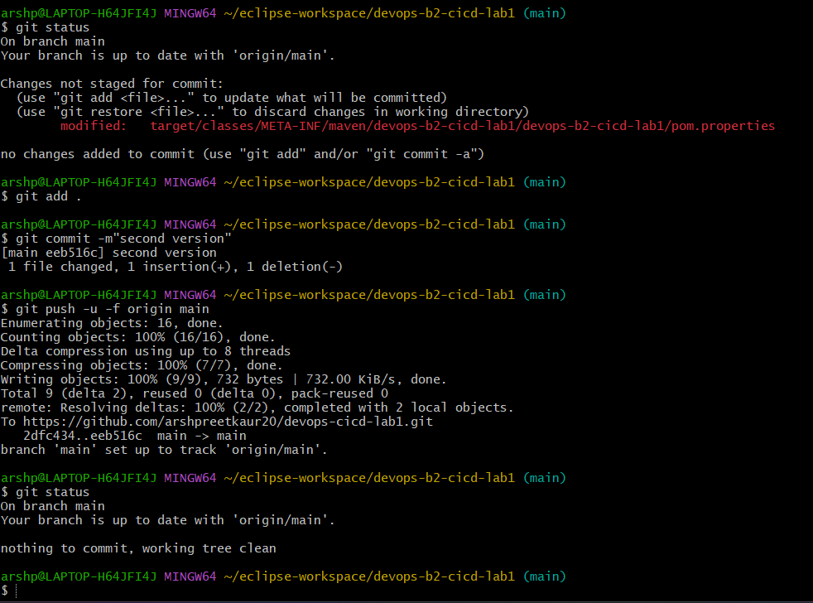

* But you have to generate this build automatically using Jenkins
* Activate Jenkins on your local system

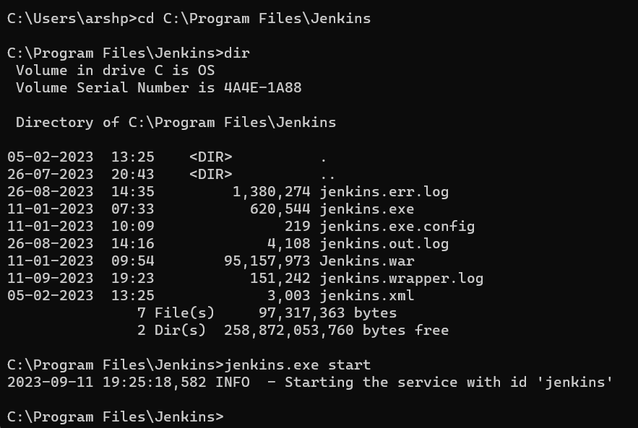

1. Go to manage Jenkins and check is maven plugin is installed or not. Manage Jenkins -> plugins -> installed plugins -> check for maven integration.

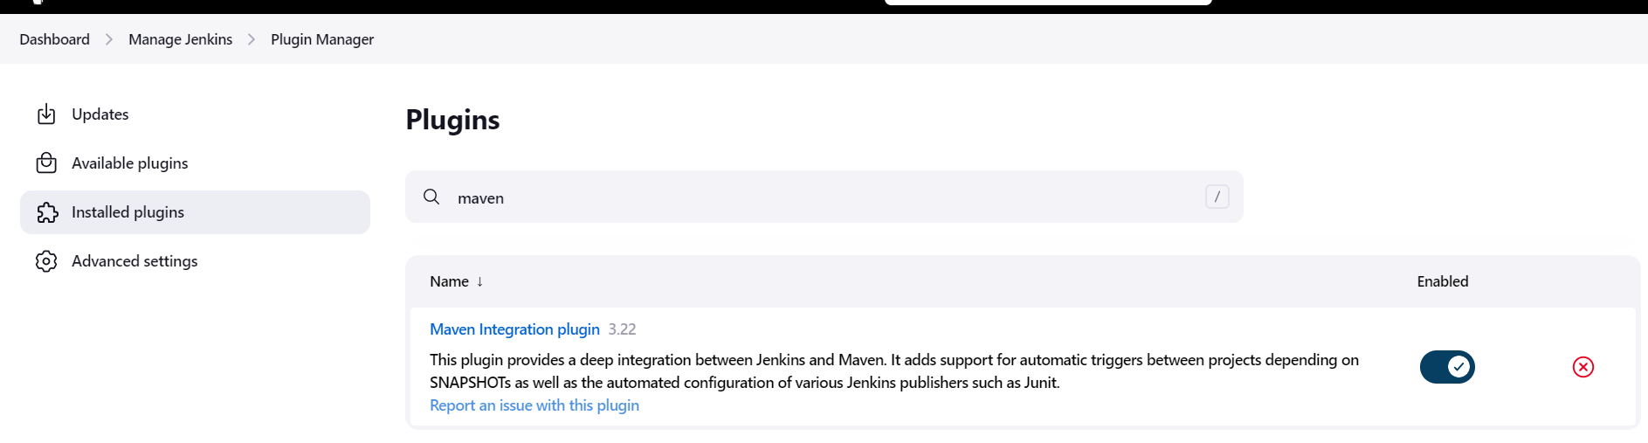

1. Go to manage Jenkins -> global tool config -> do maven configuration

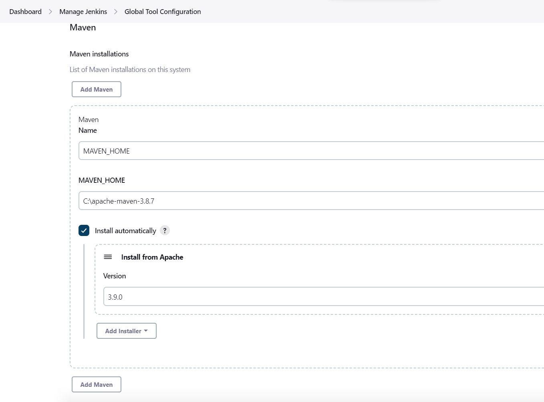

1. Go to Jenkins -> dashboard -> new item -> give name and select maven

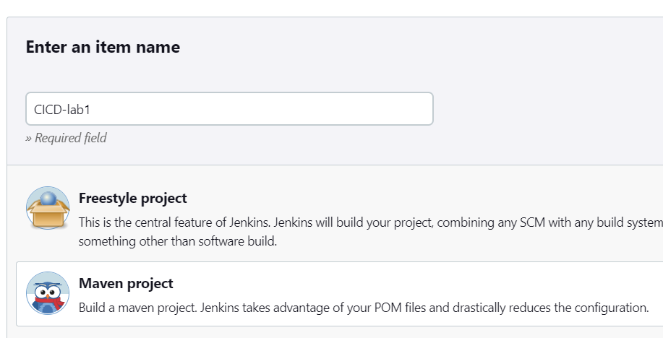

1. Go to SCM section and give git credentials as-

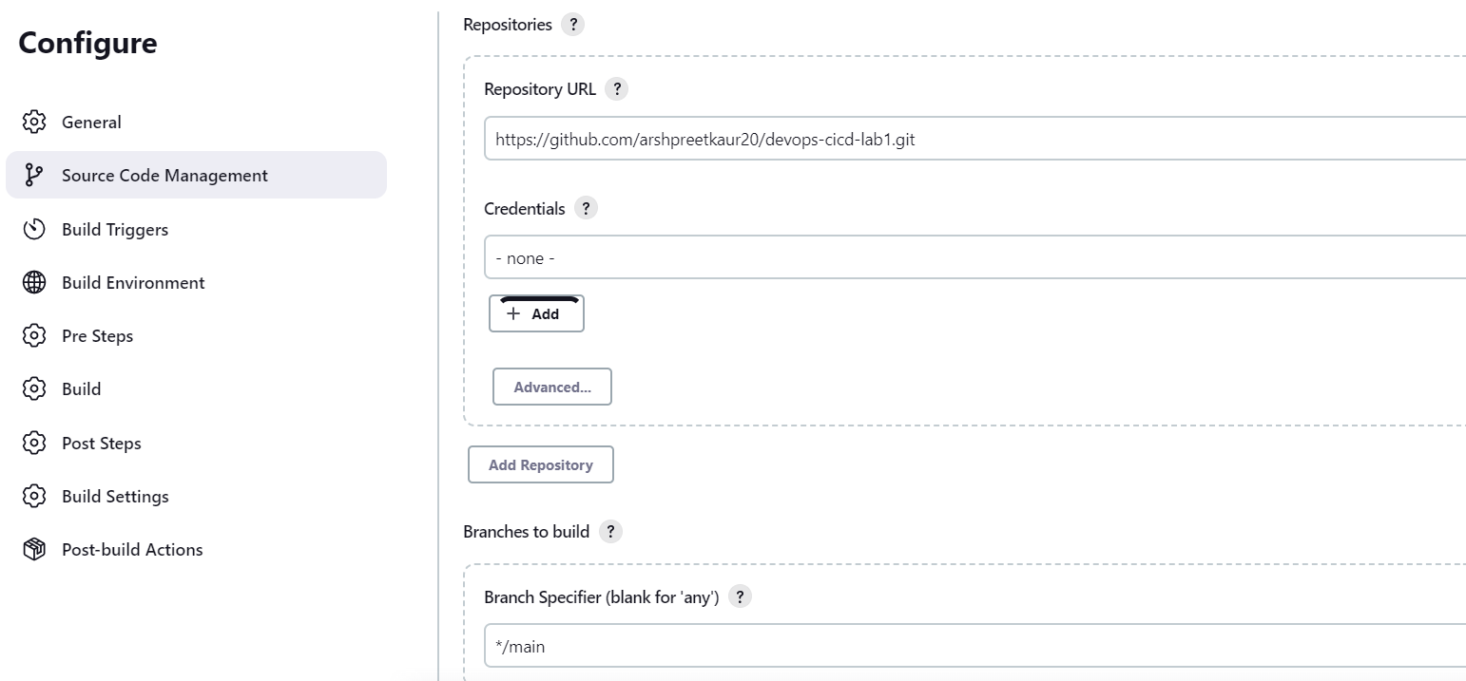

1. Go to build and give goal “install” and save it

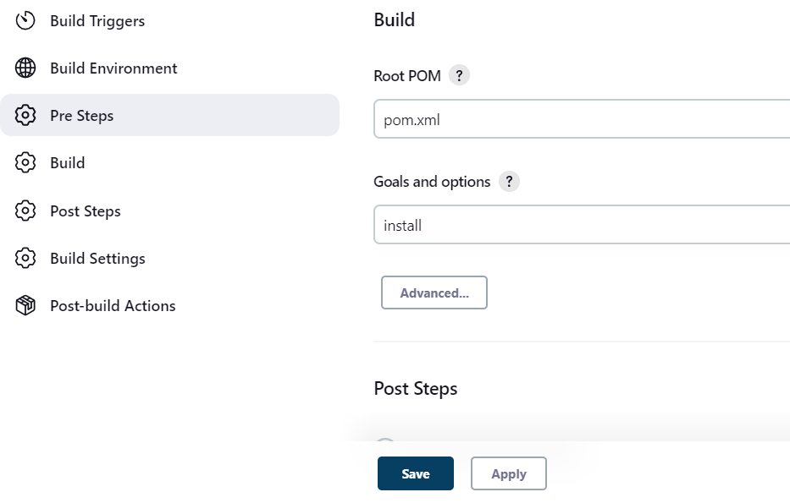

1. Build it now

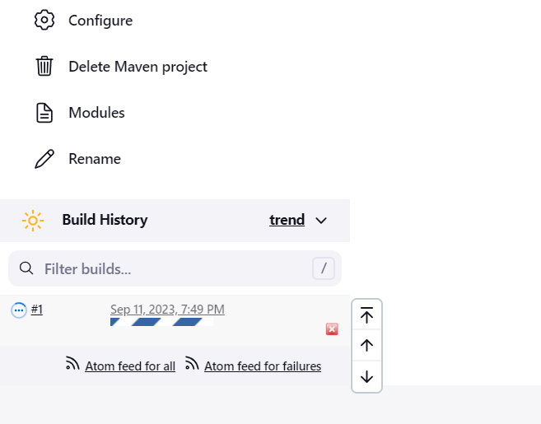

1. See the build console output, it shows build success

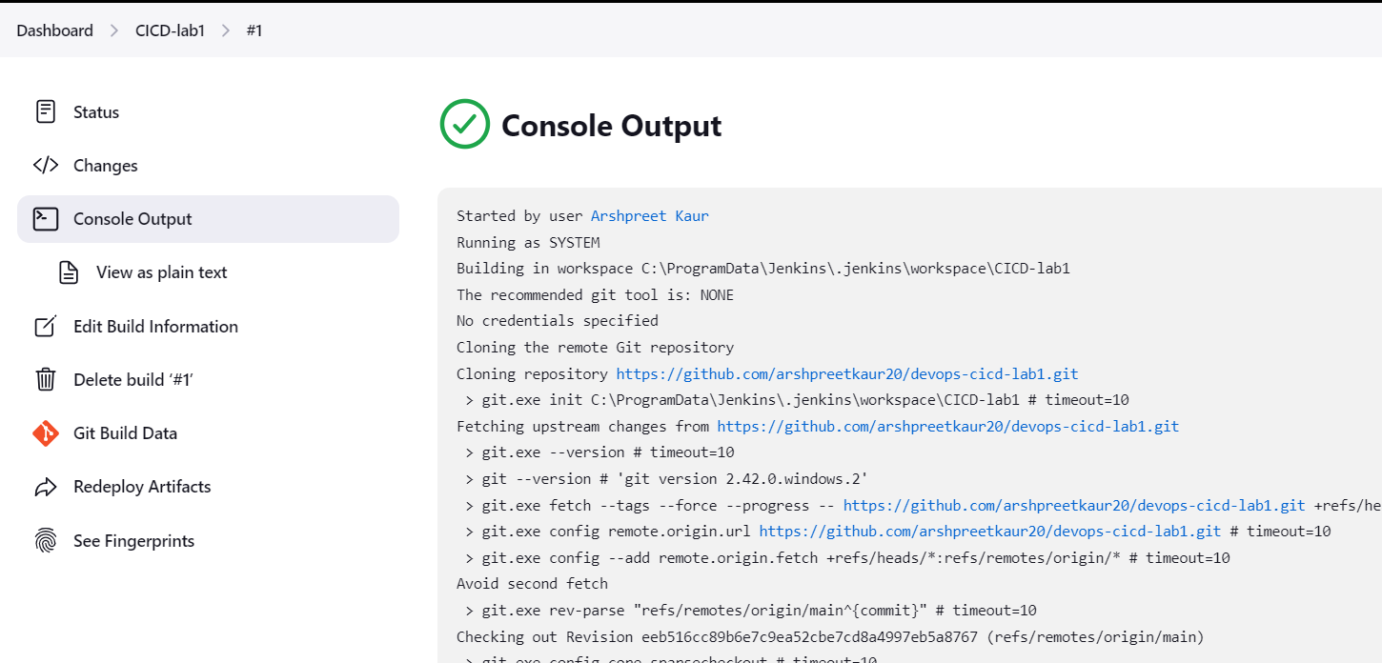

1. To trigger build automatically, go to configure -> build trigger -> poll SCM

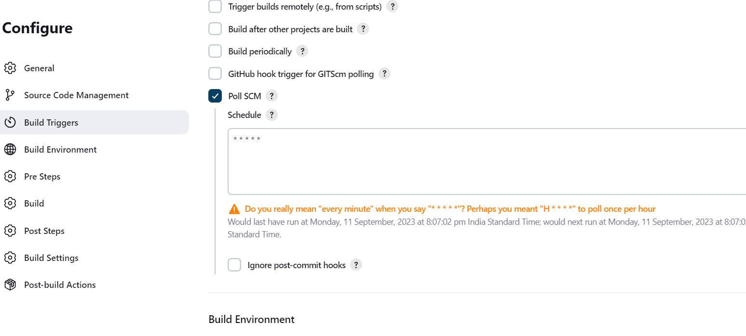

* Save it and make changes to the maven project
* Push the maven project and build on Jenkins would be automatically triggered.

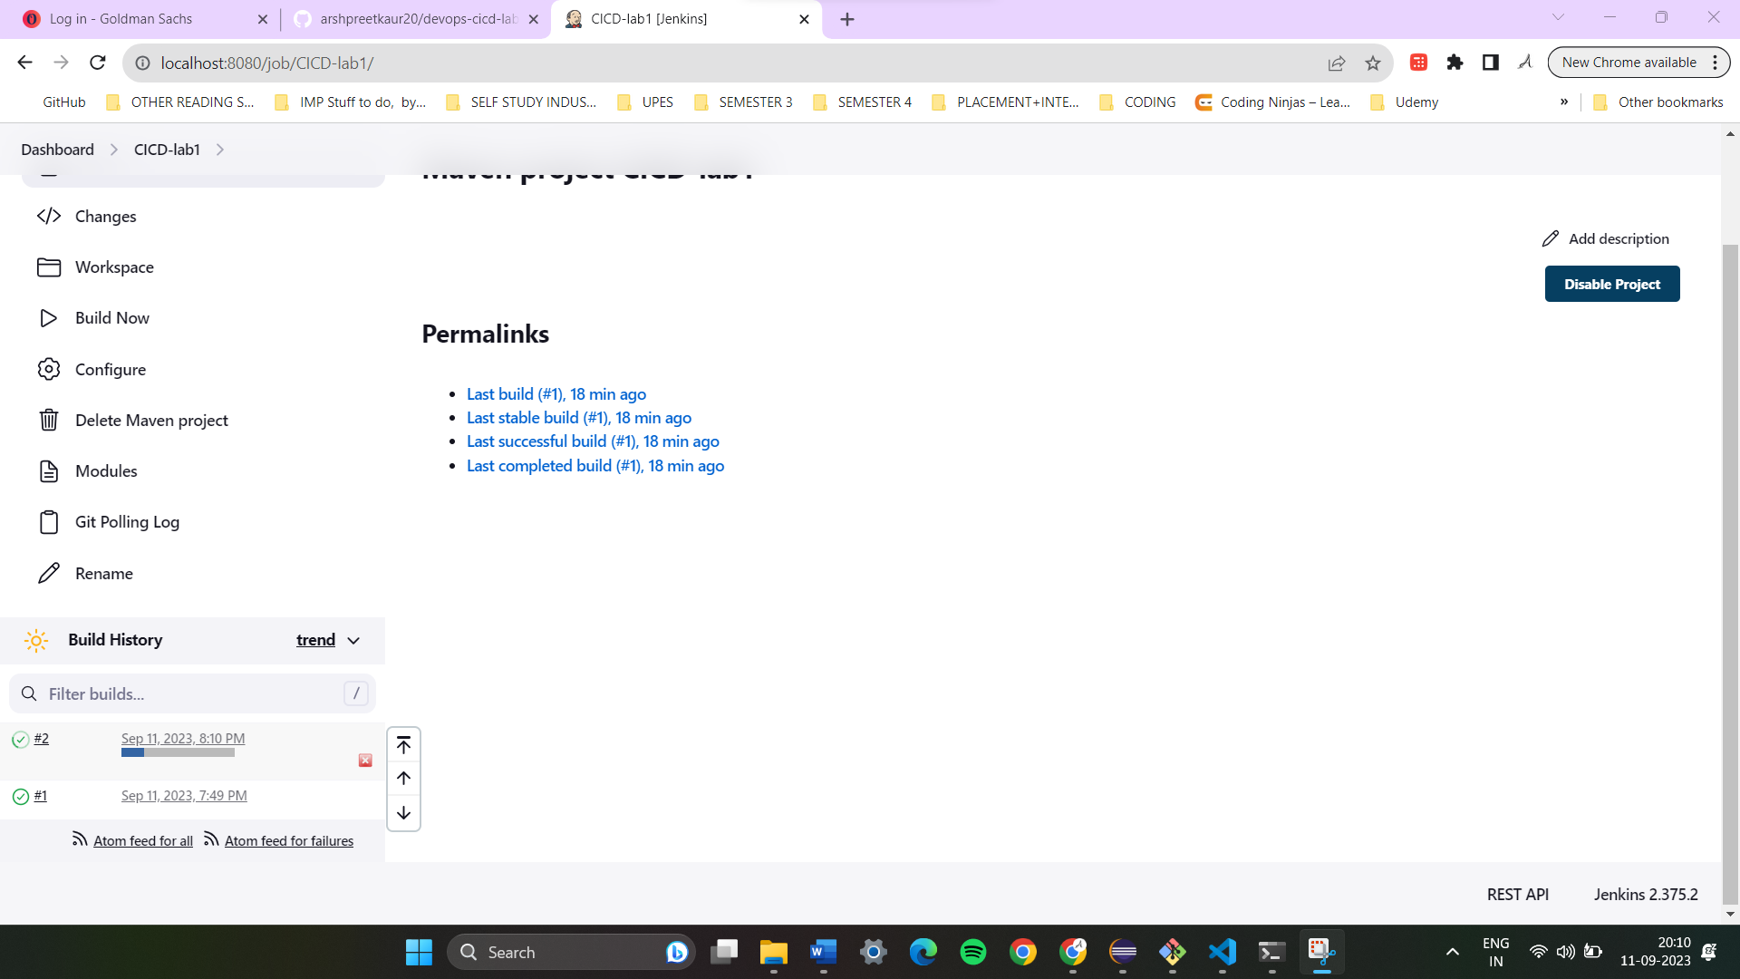

* Stop Jenkins

